**Use Case：Set reminders and modify plans**

|  |  |
| --- | --- |
| Use Case | Set reminders and modify plans |
| Related Requirements: | REQ7，REQ8 |
| Initiating Actor | User |
| Actor’s goal | The user needs to set the departure reminder time or modify the travel plan before departure. |
| Participating Actors: | user database |
| Preconditions | The user enters the software to set the departure time or modify the plan. |
| Postconditions |  |
| Flow of Events for Main Success Scenario | 1. The user logs in to the software and enters the user interface.  2. Click the setup option to set the desired travel time  3. Data information is transferred to the database  4. The software system manages the processed information and reminds the user to travel at a predetermined time.  5. Change travel plan or cancel in user settings.  6. Data information submitted to the database  7. The software system prompts that the travel information has been successfully changed or cancelled successfully. |

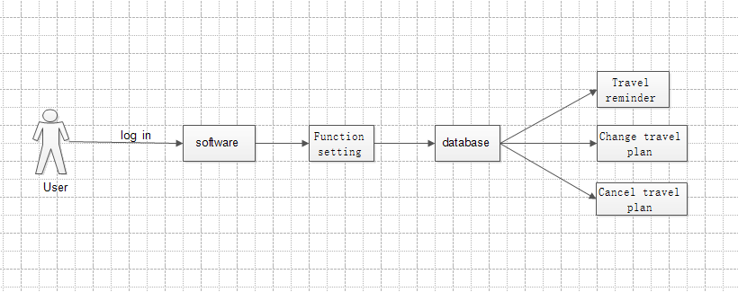

Use Case ：Query route

|  |
| --- |
| Use Case ：Query route |
| Related Requirements: REQ2 and REQ3 Initiating Actor: User  Actor’s Goal: To locate and get directions Participating Actors: Traffic database, User  Preconditions: The user registers and logs in to the software, and the software locates the user in real time and analyzes the data.  Postconditions: The software records the navigation route in the traffic database  Flow of Events for Main Success Scenario:   1. The user logs in to the navigation software. 2. The system updates the map to locate the user's location in real time. 3. The system prompts the user to enter a destination. 4. The user enters the destination and submits. 5. The system prepares a data query that best matches the user's search criteria. 6. Through the traffic database query, the system handles. 7. Data feedback and plan the best route. 8. System (a) displays the selected record and confirms the request; (b)   archives the request in the database and routes it; (c) displays the route and navigates in real time. |

